Implementation of Indoor Localization using Wi-Fi

Objectives: Implementing an indoor localization system to track the real-time locations of

occupants in building using RF-fingerprinting scheme and machine learning.

Chapter 1: Implementation of Open Source localization platform called Anyplace

Abstract: *Since technology growing so quick, interaction with internet is one of the pillar. Thus, people do most of their activities People do most of their activities, business, commerce, entertainment and socializing indoor, which is mainly aided by online services and as the indoor environment changes and gets bigger, the demand of using cost-effective indoor localization, mapping, navigation and information services increases. In this phase of the project we tried to implement on Wichita State University Jabara Hall second floor one of the Indoor Information Services coined Anyplace [1], which has an open source, modular, extensible and scalable architecture, making it ideal for a wide range of applications.*

Introduction:

The rapid growth of the Technology market paves the way to realize the Indoor Information Services using positioning rich Mobile phones and Wi-Fi Access Points with in the indoor environments. Indoor positioning systems (IPSs) have been designed to provide location information of persons and devices but still accurate, reliable and real-time indoor positioning and position-based protocols and services are required in the future generation of communications networks [2]. A positioning system enables a mobile device to determine its position, and makes the position of the device available for position-based services such as navigating, tracking or monitoring, etc. Some position-based indoor tracking systems have been used in hospitals, where expensive equipment needs to be tracked to avoid being stolen, and the patients can get guidance to efficiently use the limited medical resources inside complex environments of the hospitals. Indoor navigation systems are also needed in a large public area to provide position indications for the users. Today’s technological market and gadget culture allow for the realization of such indoor services with the omni-presence of sensor-rich mobile devices and Wi-Fi *Access Points (APs)* in indoor environments. Mobile phones can measure the signal strength received from surrounding APs and receive information on their location based on geolocation databases, which maintain information about those APs (i.e., the signal intensity of these transmitters at known locations in space) [1]. The uncertainty in dynamic and changing indoor environments is reduced by the availability of position information. valuable position-based applications and services for users in Personal Networks(PN) are enabled by location context offered by Indoor Positioning Systems(IPSs) in various places such as homes, offices, sports centers, etc. Indoor positioning is one of the important techniques to make context-aware services feasible. Many domains get benefits from indoor location information of mobile units to provide useful applications and services, such as museum tour-guide and location-based handoff.

Many positioning techniques have been proposed and they can be classified in to the following categories [4]:

1. Time of Arrival(TOA)
2. Time Difference of Arrival (TDOA)
3. Angle of Arrival (AOA)
4. Location Fingerprinting

Not all these four techniques are suitable for indoor positioning because of the complexity in the indoor environments. The Location Fingerprinting use the received signal strength (RSS) at the sampling locations to build a "radio map" for the target environment. This RF Fingerprinting has two stages [4]: Off-line and On-line. During the Off-line stage, site survey is performed in the target environment to collect the RSS from nearby base stations at sampling locations. In the on-line stage, the positioning techniques measure the RSS in real-time and calculate the estimated location coordinates based on the knowledge built during the off-line stage.

In this chapter of Indoor Localization Implementation, we mainly concentrate on implementation of a unique IPS called Anyplace. As Anyplace uses Radio Frequency Fingerprinting Techniques over the Wi-Fi infrastructure for better indoor navigation, creates efficient way verify the expected implementation procedure of this open source localization platform with Wireless Mesh Software Defined Networking testbed consisting of TP-Link wireless routers running open source routers OS “OpenWRT”.

Project Objective:

The main objective of this chapter revolves around experimenting means through technicalities for Anyplace Positioning system over the Jabara Hall second floor as the target testing area using the open source of Anyplace with the following module implementation objectives:

1.Implement Architecture Module

2.Implement API Module

3.Implement Viewer Module

4.Implement Client on Android OS with all real-time interaction phase

As Anyplace is modular architecture that allows to plug and play additional modules, either for extending system capabilities by implementing new features (e.g., activity recognition, indoor/outdoor transition), or for enhancing user-experience by improving existing functionalities (e.g., map-matching and sophisticated data fusion to increase localization accuracy) [1].

Anyplace System Architecture [1]:

As System Design Architecture point of view, it has three major parts. The Front End, The Middle and the Back end. Each Architectural Parts comprises of specific elements with different performance parameters.

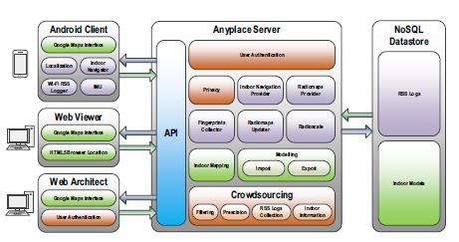

Figure 1: Anyplace System Architecture

1. Front End:

The front end comprises of three parts, and these are the Android Client, the Web Viewer and Web Architect. The Android Client will do the combined function of Navigationand *Logging* and are designated tool for only Android users, which can benefit from Wi-Fi fingerprinting available under this platform. The Web Viewer and Architect are both a web app to do the quick visualization of buildings modeled and to give feature-rich, user friendly, account-based interface for managing indoor models in Anyplace respectively.

**Side Note**: The Developer team have chosen AngularJS to build their front-end views. AngularJS is a JavaScript framework powered by Google. In addition, they are using Cordova to facilitate producing the same code base to mobile application such as Android or Windows.

1. Middle (Server)

The *Server* delivers indoor navigation directions to the user upon request based on the Radio-maps stored. The *Server* features several modules that perform crowdsourcing functionality. The *Server* follows a big-data architecture and provides a Web 2.0 API using JSON objects for mapping, navigation and localization.

1. Database (Back End)

The Backend Database is Non-SQL(NoSQL) called Couchbase Server which provides a mechanism for storage and retrieval of data which is modeled in means other than the tabular relations used in relational databases. It uses Couchbase as its back-end database for scalability and fast metadata retrieval.

**Side Note** : Couchbase[5] is an [open-source](https://en.wikipedia.org/wiki/Open-source), distributed ([shared-nothing architecture](https://en.wikipedia.org/wiki/Shared-nothing_architecture)) model NoSQL [document-oriented database](https://en.wikipedia.org/wiki/Document-oriented_database) software package that is optimized for interactive applications. These applications may serve many [concurrent users](https://en.wikipedia.org/wiki/Concurrent_user) by creating, storing, retrieving, aggregating, manipulating and presenting data. In support of these kinds of application needs, Couchbase Server is designed to provide easy-to-scale key-value or JSON document access with low latency and high sustained throughput.

Projective Objective Implementation:

Task I. Implement Architecture Module

This task has been done using anyplace website which gave us the ability to upload and manage buildings and point of interest (POI) We started our experiment by adding Jabara Hall’s second floor map, we add some point of interest (POI) as shown in the figure 2. Below.

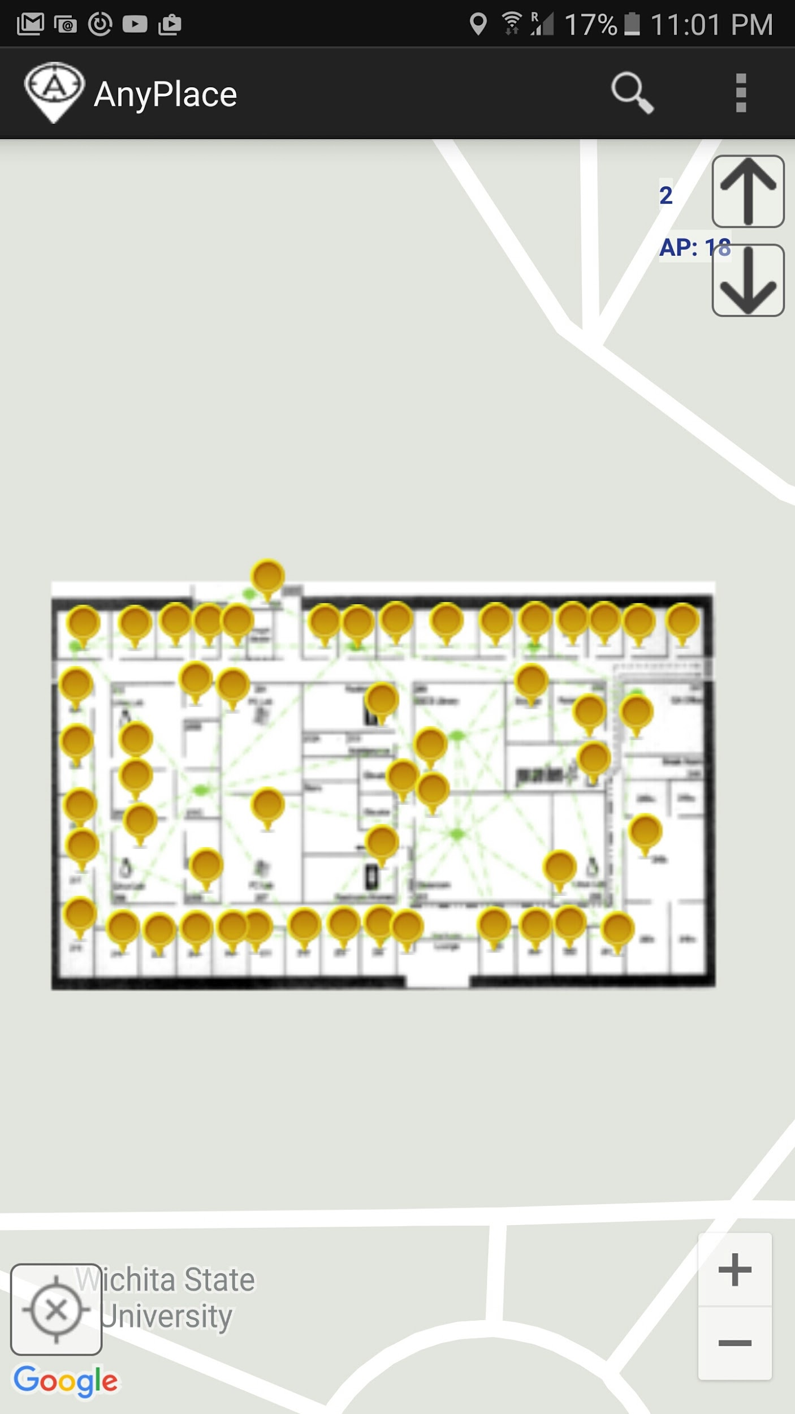

Figure 2. Jabara Hall Second Floor map

Task 2. Implement API Module

We use this module for logging fingerprints of the RSS. To acquire this task, we planned to collect the survey data in High volume with different time and different pattern throughout the second floor of Jabara Hall. Doing the survey (Collecting the RSS data) gives more accuracy and efficiency for the on-line stage during Navigation stages. We did one hundred rounds of the Jabara Hall with different time, date and pattern as well.

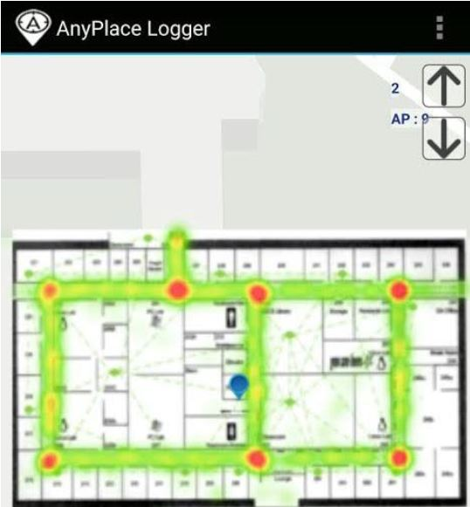

Figure 3: Survey result (100 surveys)

Task 3: On-Line Stage (Implementation Phase)

This test phase was done by randomly select two points and checking the accuracy of the Anyplace for giving the navigation based on the survey. Thus, we selected the initial point Beggs hall building to the final point be office 214 in Jabara hall. Figures (4,5) show the results of our implementation.

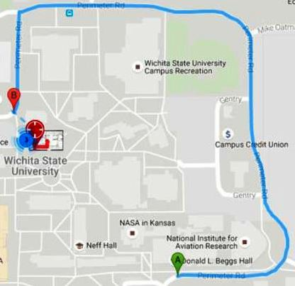

Figure 4: Navigation from Beggs Hall to office 214 at Jabara Hall (GPS+ Anyplace)

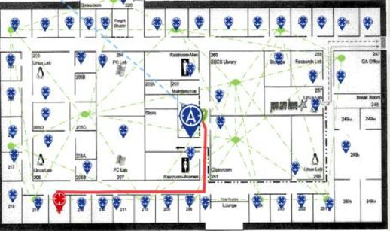

Figure 5: Navigation from Beggs Hall to office 214 at Jabara Hall(Anyplace)

Challenges:

Even if success curve was very promising while we were on implementation phase, there was few but critical problems that we came across. These are as follows

1. During samples collection phase we ran into issues in term of mesh network connectivity. The first issue is in some areas the connection to mesh network is lost which might be caused by inappropriate access points positions.
2. Another challenge we faced is instability of internet access from mesh network. These challenges made it hard for us to collect more samples to increase the accuracy of the results.
3. Even though Anyplace has an open source for the front-end modules but the logic and Algorithm that runs inside the server is kept hidden which mainly creates hardship on sample classification, and impossible to add customization functionalities with the current Anyplace architecture.

Because of the mentioned challenges, we initiated a new project to provide a similar Indoor localization functionality using our own implementation. The next chapter shows our milestone benchmarks to achieve some functionalities.

Chapter 2. Designing and Implementing a new model of indoor Localization

Mile Stone

Define used technologies:

* Python 2.7
* Mysql or MongoDB
* sqlalchemy for interfacing with database
* Django framework
* Rest Framework to create RESTful API

Define System Architecture

Setup a server with all dependencies

Implement RSSI logger on laptop

Implement RSSI Parser

Implement RSSI Logger on Android

Research and implement Machine Learning classification

Reference:

[1]. Anyplace: A Crowdsourced Indoor Information Service:

Kyriakos Georgiou, Timotheos Constambeys, Christos Laoudias ,

Lambros Petrou , Georgios Chatzimilioudis and Demetrios Zeinalipour-Yazti

kgeorg10, tconst02}@cs.ucy.ac.cy; laoudias@ucy.ac.cy; lambros.petrou@wolfson.ox.ac.uk;

{gchatzim, [dzeina}@cs.ucy.ac.cy](mailto:dzeina%7d@cs.ucy.ac.cy)

2. A Survey of Indoor Positioning Systems for Wireless Personal Networks:

Yanying Gu, Anthony Lo, *Senior Member, IEEE,* and Ignas Niemegeers

3. C. di Flora, M. Ficco, S. Russo, and V. Vecchio,”

Indoor and outdoor location based services for portable wireless devices”,

*Proc. 25th IEEE International Conference on Distributed Computing Systems Workshops*,2005.

4. Performance Comparison of Indoor Positioning Techniques based on Location Fingerprinting in Wireless Networks:

Tsung-Nan Lin, Po-Chiang Lin:Graduate Institute of Communication Engineering

National Taiwan University, Taipei, Taiwan Email: {tsungnan, r92942075} @ ntu.edu.tw

5. http://www.couchbase.com/nosql-resources/why-nosql